EE303B Fall 2017

**Report on Lab#3**

Nov. 23, 2017

Student No. 20160042

Koo InYong

Email: [iykoo010@kaist.ac.kr](mailto:iykoo010@kaist.ac.kr)

**Part I. Design and Simulation of 16-bit Add-Sub accumulator with reset using 16-bit ripple-carry Adder with delay**

1. **Design (Verilog coding) of 16-bit Add-Sub accumulator with reset using 16-bit ripple-carry Adder with delay (DUT: AddSubOvf_16b_dly.v)**

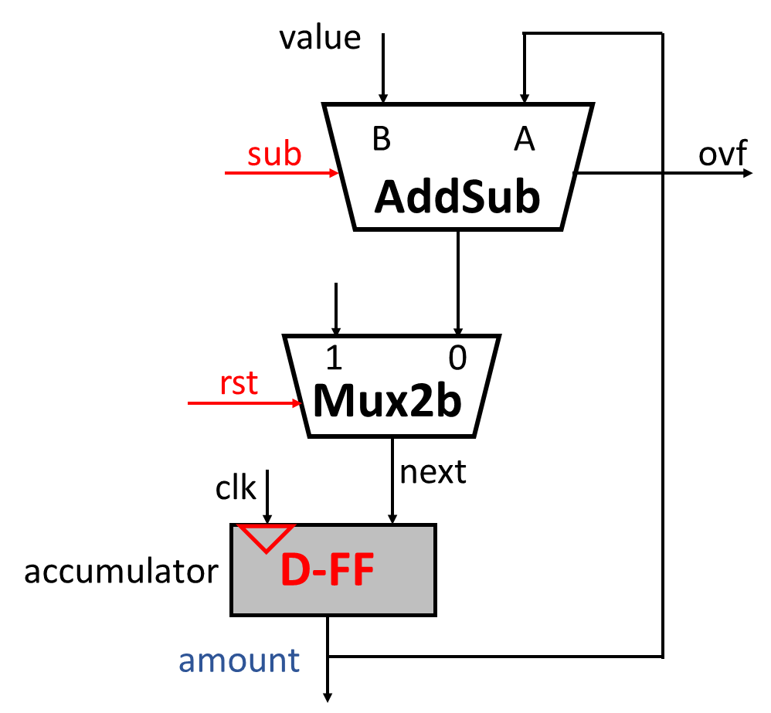

*Design (Verilog Coding) 16-bit Add-Sub accumulator with reset using 16-bit ripple-carry Adder with delay by coding with following three sub-functional blocks:*

*- AddSub with ovf circuit using 16 adder_1b_dly blocks, 16XOR gates with ‘sub’ control signal and an overflow detection logic.*

*- 16-bit 2-to-1 multiplexer, Mux2b, with a select signal ‘rst’.*

*- 16-bit accumulator using 16 DFFs.*

Verilog code for AddSubOvf_16b_dly.v is as following.

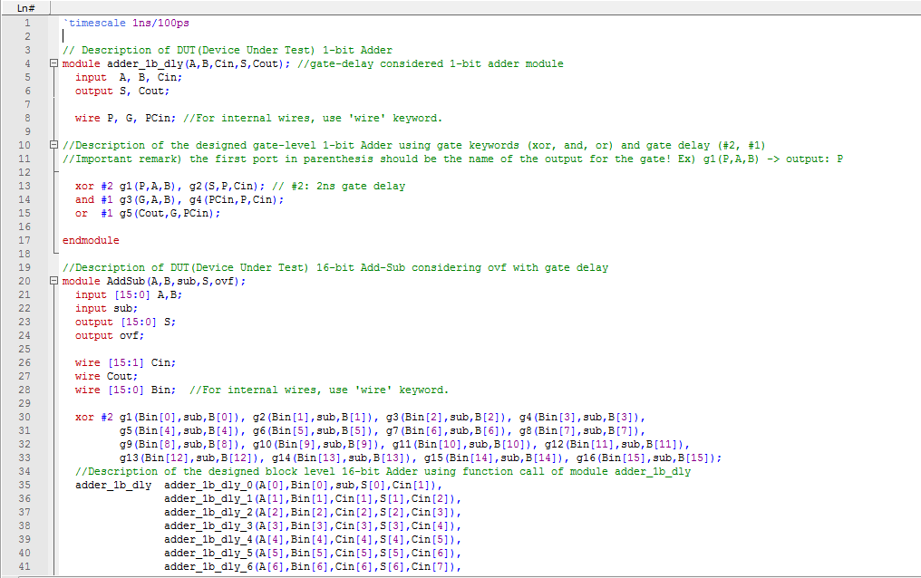

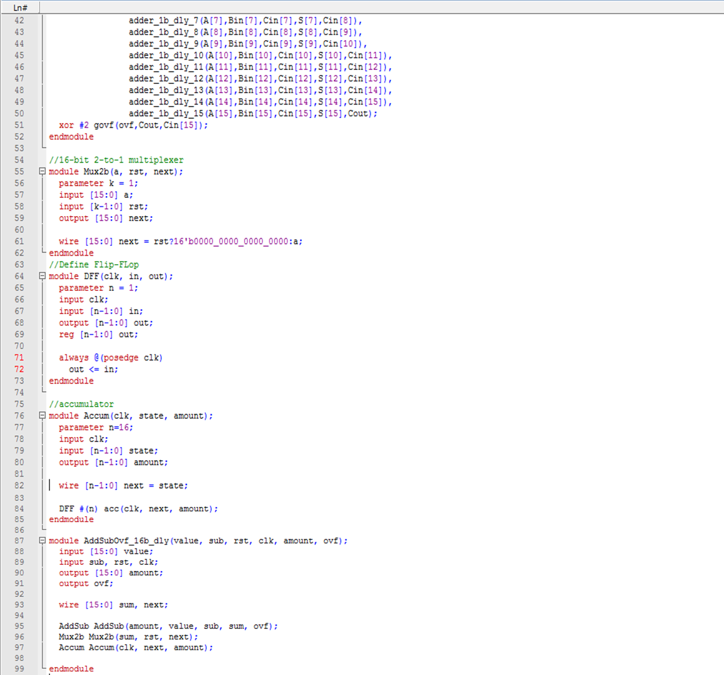

1. **Simulation of the DUT by including the following clock generation and stimuli in the testbench (TB: TB_AddSubOvf_16b_dly.v)**

Verilog code for given TB_AddSubOvf_16b_dly.v is as following.

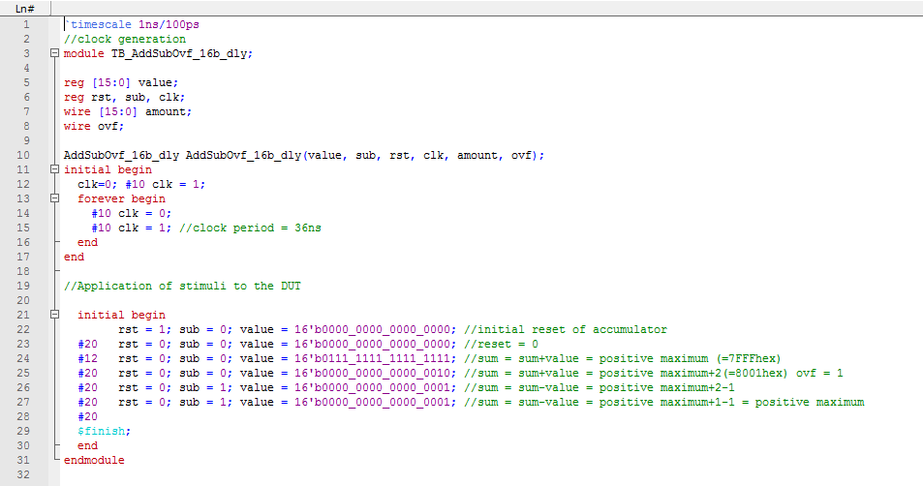

Following waveform is the result obtained by given testbench code.

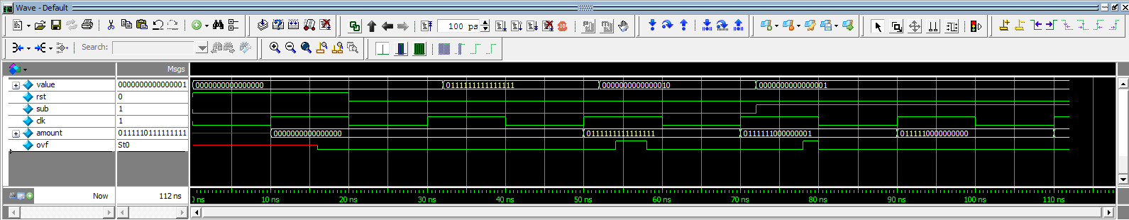

1. **Evaluation**
2. *Check the accumulated results. If they are not correct, explain their reasons and propose the minimum clock period condition to solve the problem. Do the correct simulation based on the minimum clock period with some margin which will give correct results.*

Result obtained from given TB_AddSubOvf_16b_dly.v is not correct. It is because clock period is smaller than the delay of AddSubOvf_16b_dly.v.

AddSubOvf_16b_dly.v have critical path delay of 36 ns (2ns from XOR gate dealing ‘sub’ + 32ns from 16-bit ripple carry adder + 2ns from XOR gate obtaining ‘ovf’).

Thus, minimum clock period condition is **36ns**.

In correct simulation, we will use 40ns clock period condition (which is bigger than 36ns) for safety and better recognition.

Modified Verilog code for TB_AddSubOvf_16b_dly.v is as following.

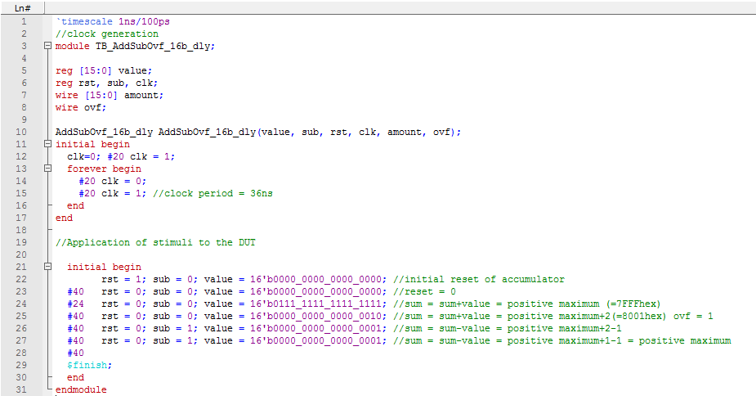

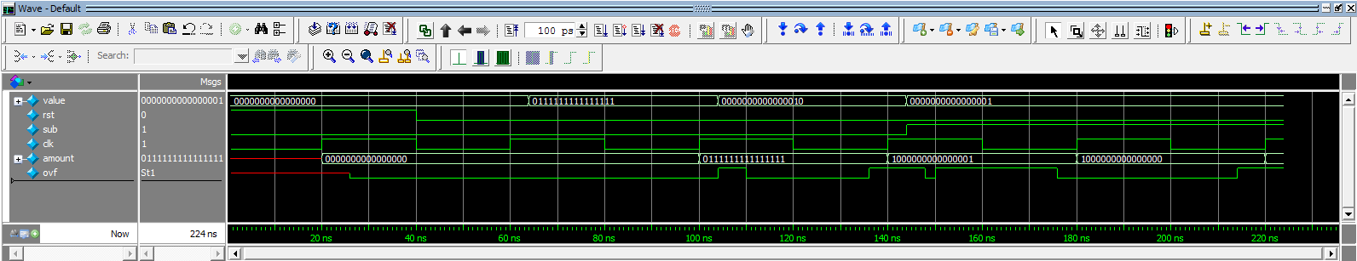Correct simulation result can be shown as following.

1. *Check an overflow occurrence of the accumulation. Explain how it is recovered when a correct simulation is done.*

We can see that overflow occurs when 2 is added on positive maximum(=7FFFhex), but it is recovered as 1 is subtracted twice, returning to positive maximum. Computation could be done without error, as we understand the numbers in accumulator as an unsigned int.

**Part II. Design and Simulation of 16-bit Add-Sub accumulator with reset using 16-bit carry-look-ahead circuit with delay**

1. **Design of the DUT**
2. **Verilog code of the DUT**
3. *To calculate the sum, include ‘sum of CLA16’ Verilog code in the code of Fig.12.6. as follows:*

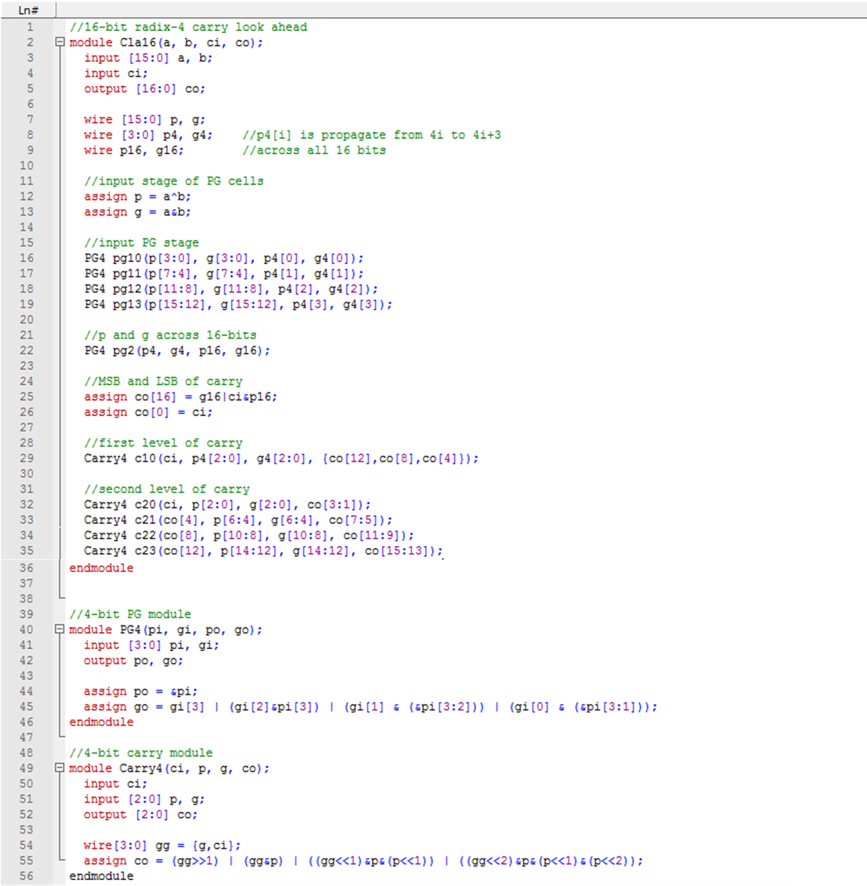

1. *Also, for delay included version of the Cla16, Cla16_dly, include delays in ‘assign’ statement as follows:*

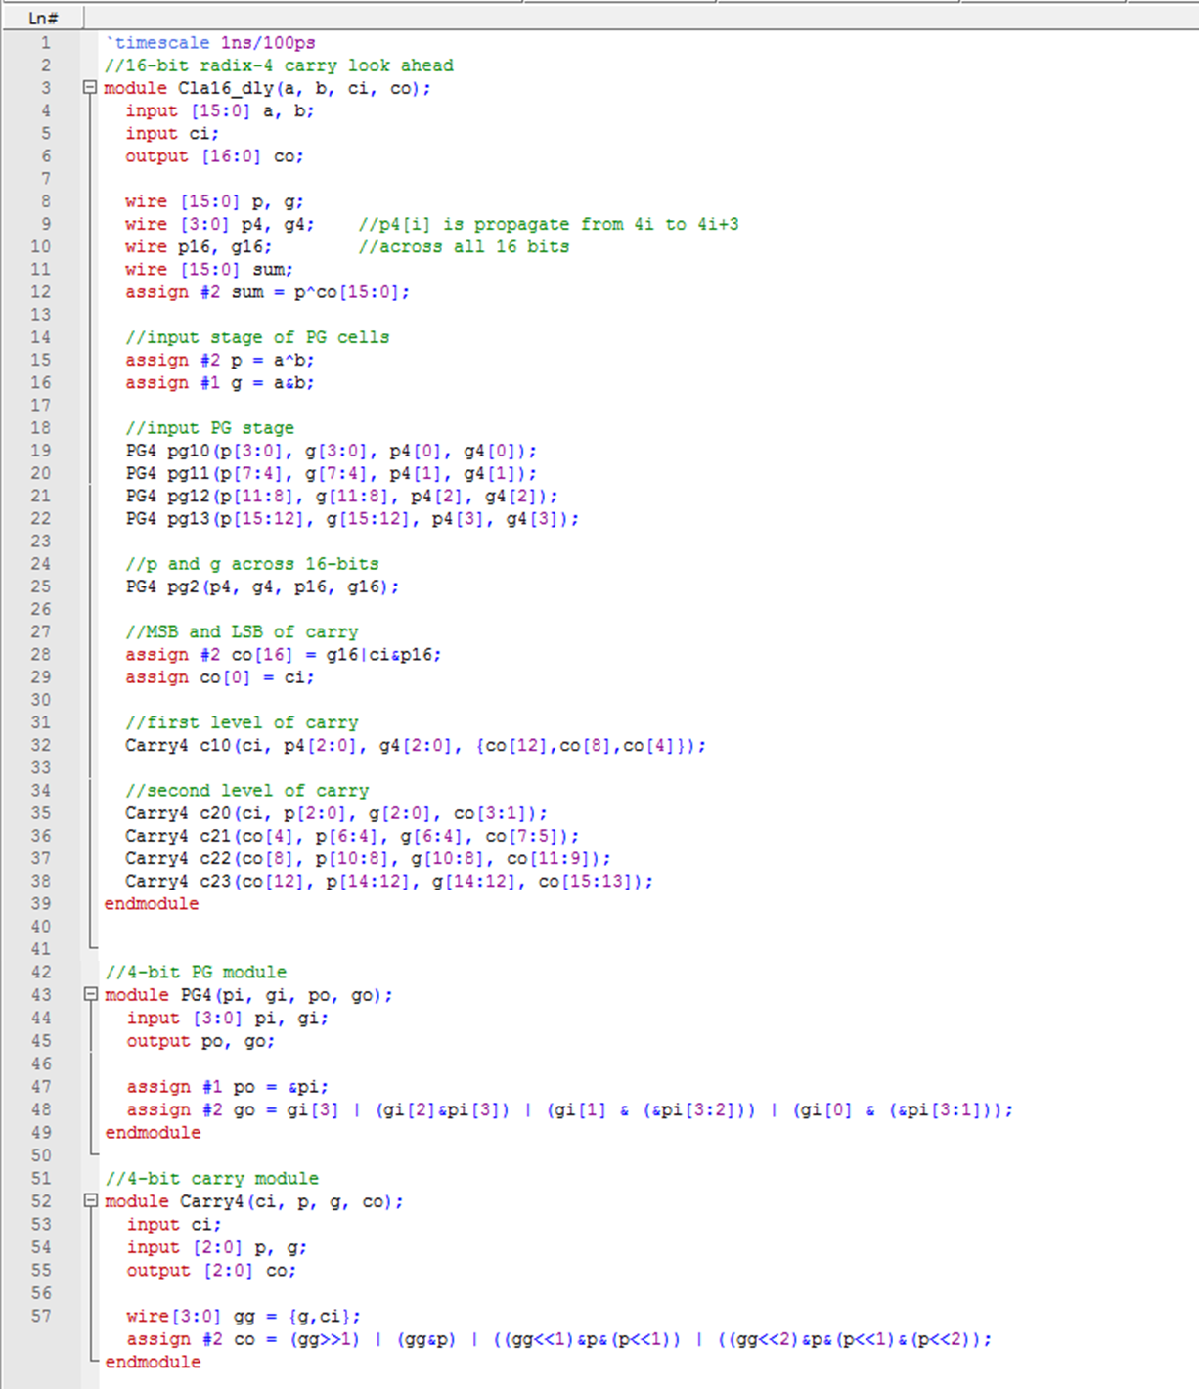

1. **Simulation of the DUT with the following stimuli:**

For testbench, use the following code:

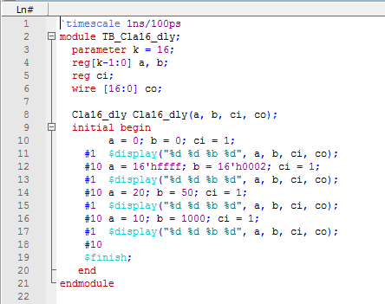

1. **Evaluation**
2. 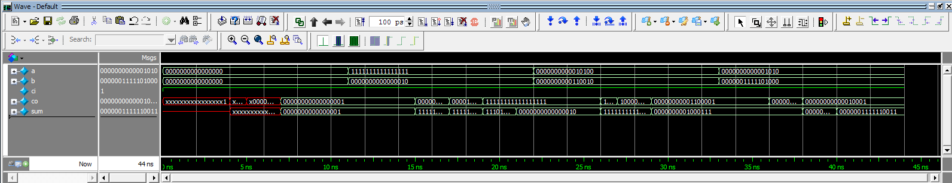*Check the simulation results. What is the critical path delay in the simulation? And verify each element of the critical path compared to the circuit of the Figure 12.5.*

The critical path delay is **10ns**.

(2ns from XOR gate obtaining p, g from a, b +2ns from PG4 module + 2ns from first level of carry + 2ns from second level of carry + 2ns from XOR gate obtaining sum from p, co)

1. *What is the gain of the delay reduction by carry-look-ahead circuit compared to that of the 16-bit ripple-carry-adder?*

As we calculated, critical path delay of carry-look-ahead circuit is 10ns, while 16-bit ripple-carry-adder circuit is 36ns. Thus, 26ns delay reduction could be obtained.

**Part III. Design and Simulation of the overflow vending machine**

1. **Simulation of the vending machine of Section 16.3.1 using PLA version DUT and TB code which can be found in the Lecture 07.**

*Do the simulation and confirm the waveform given in the Lecture 07 with those you simulate.*

Verilog Code of VendingMachine_pla.v is as following:

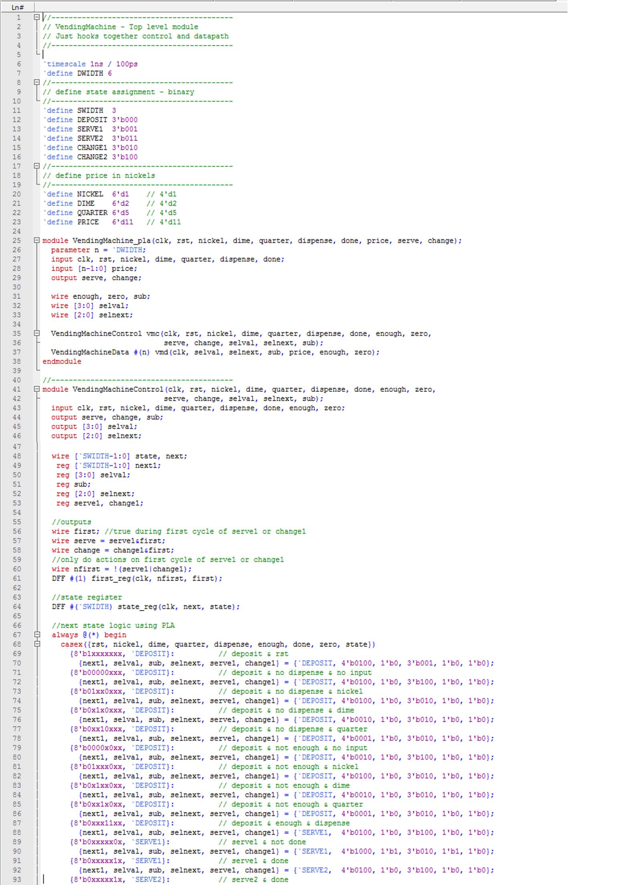

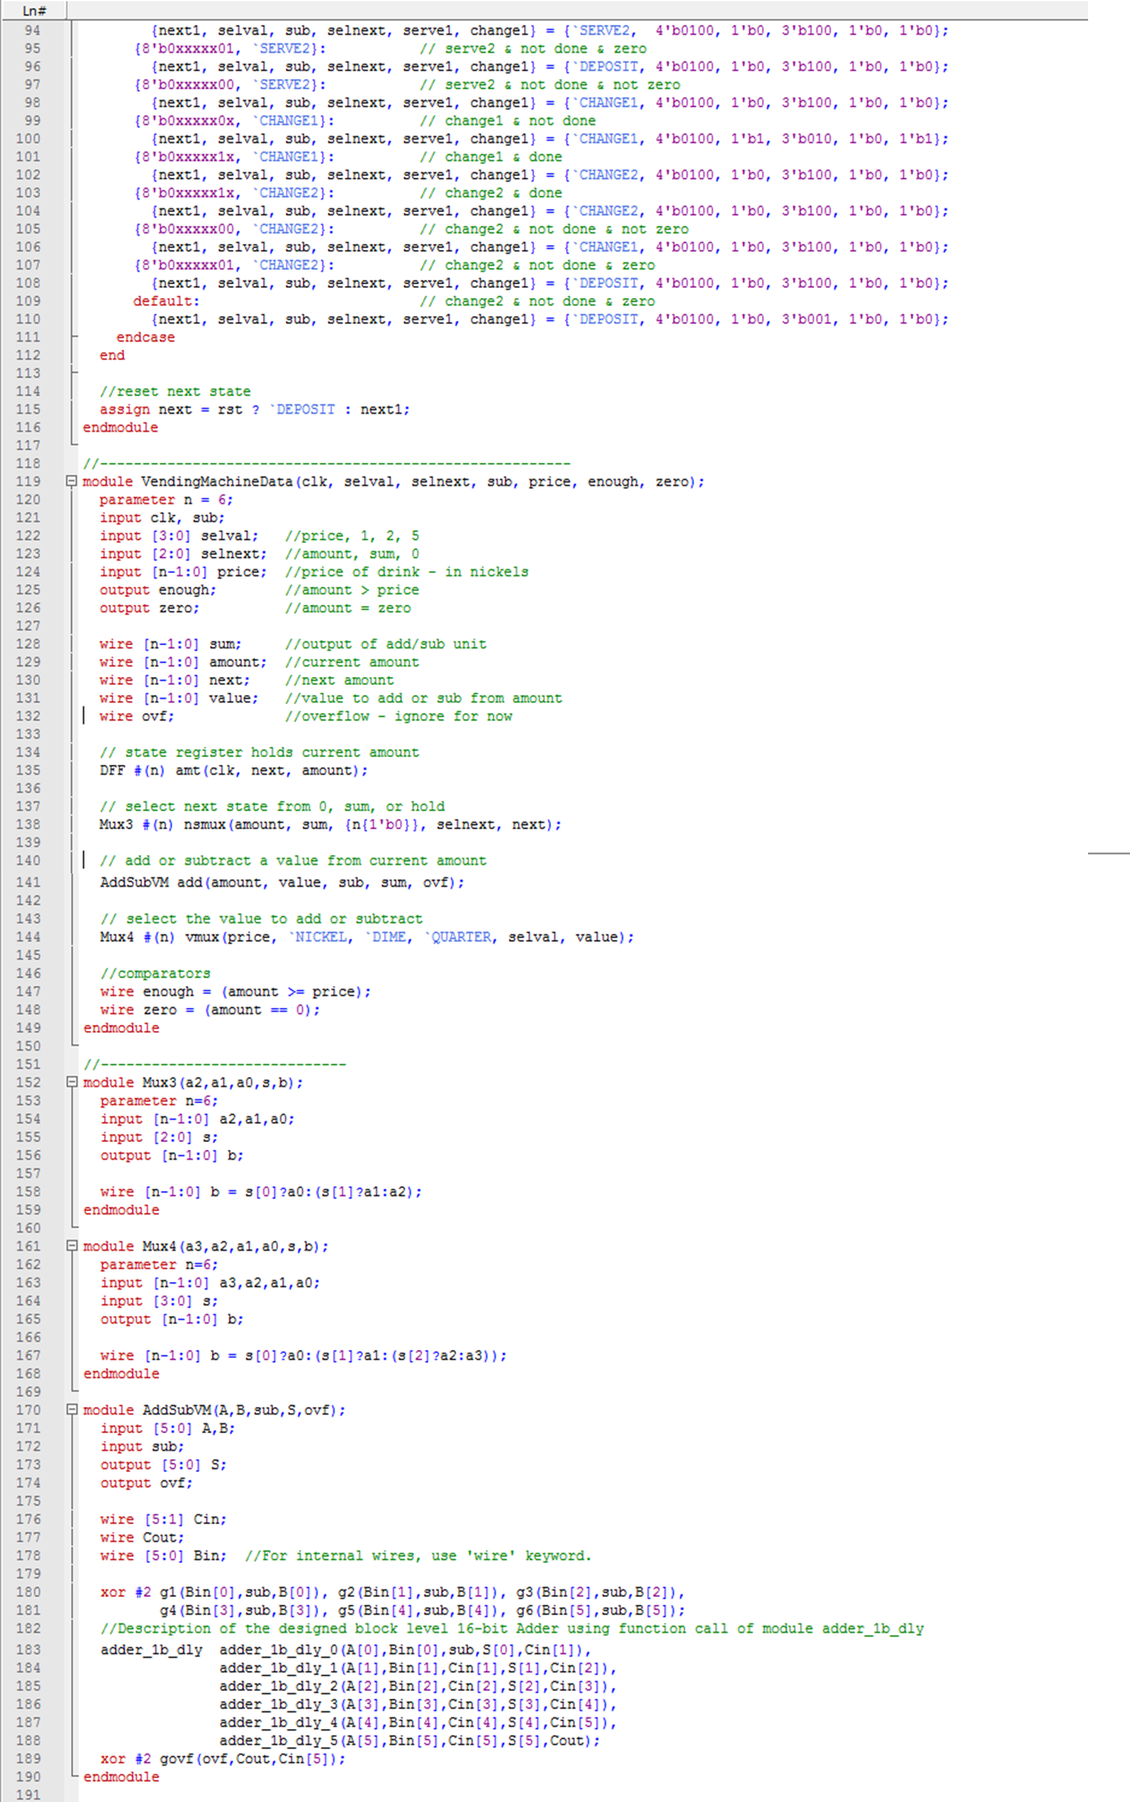

Verilog code of TB_VendingMachine_pla.v is as following:

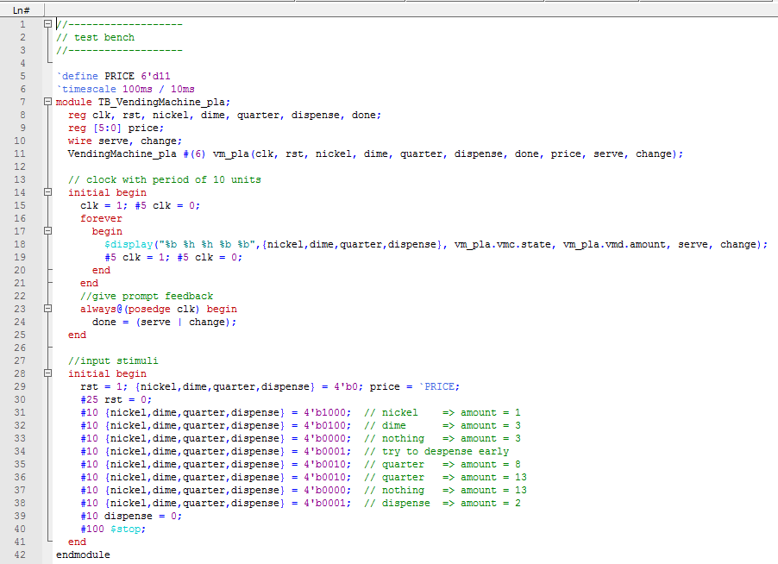

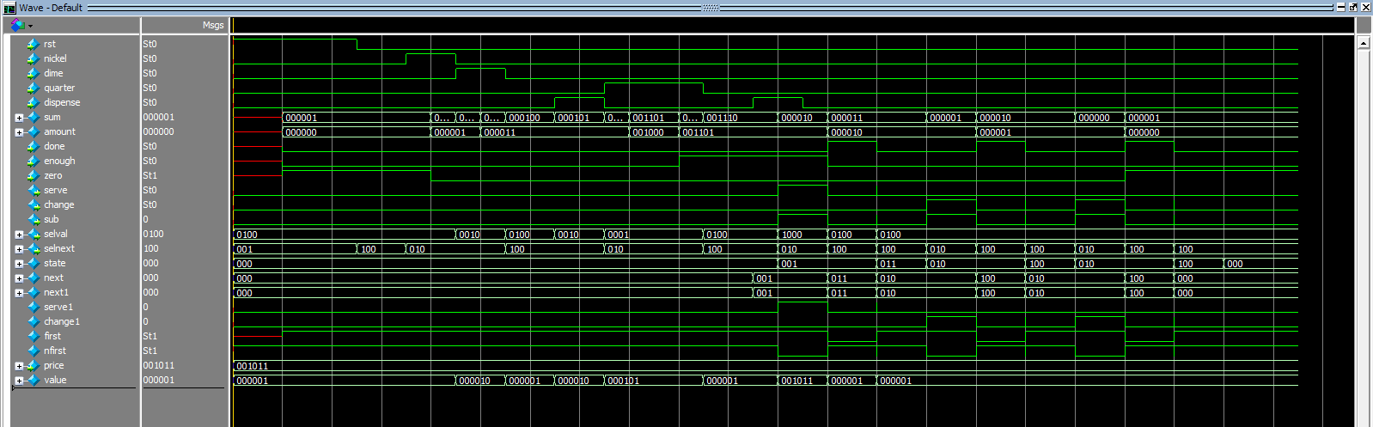Simulation result is as following:

It is identical with the simulation result shown in the lecture 07 Slides.

1. **Design of a modified version of the vending machine of Section 16.3.1 Vending machine II as follows:**

*Exercise 16.11 Modify the vending machine of Section 16.3.1 in the following manner. If the user keeps inserting money into the current implementation, the counter could overflow. Design the vending machine to have a saturating add that returns excess coins to the user.*

*- State graph is given as follows:*

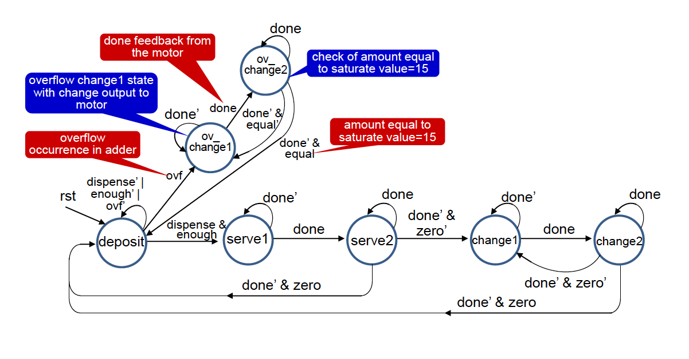

1. **Simulation**
2. **Coding of DUT**

**modification of the DUT Verilog of the vending machine is as follows:**

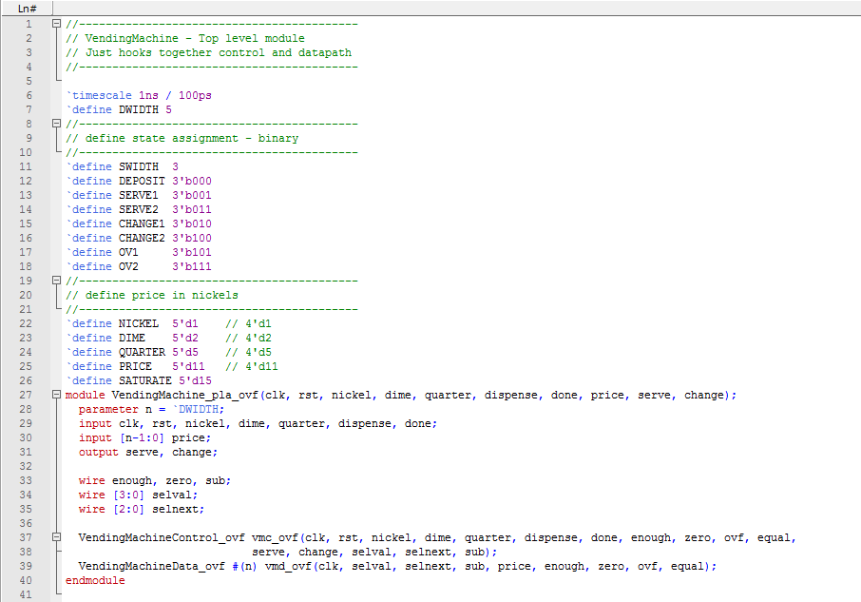

1. ***Modification of Vending Machine control in Verilog using PLA for overflow***

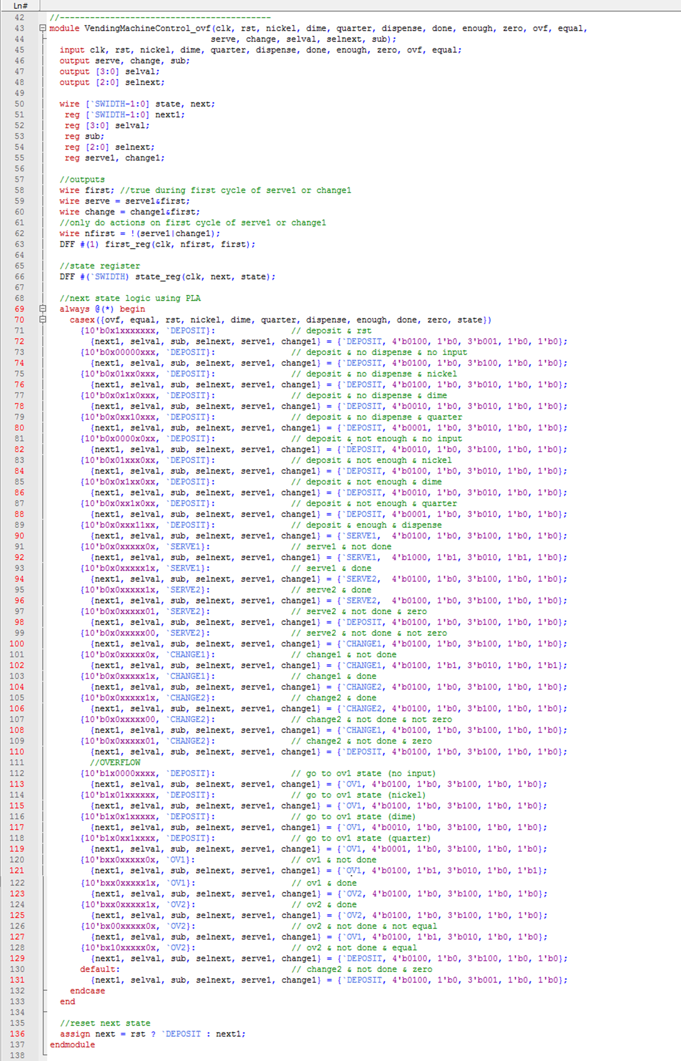

1. ***Modification of Vending Machine Data in Verilog using PLA for overflow***

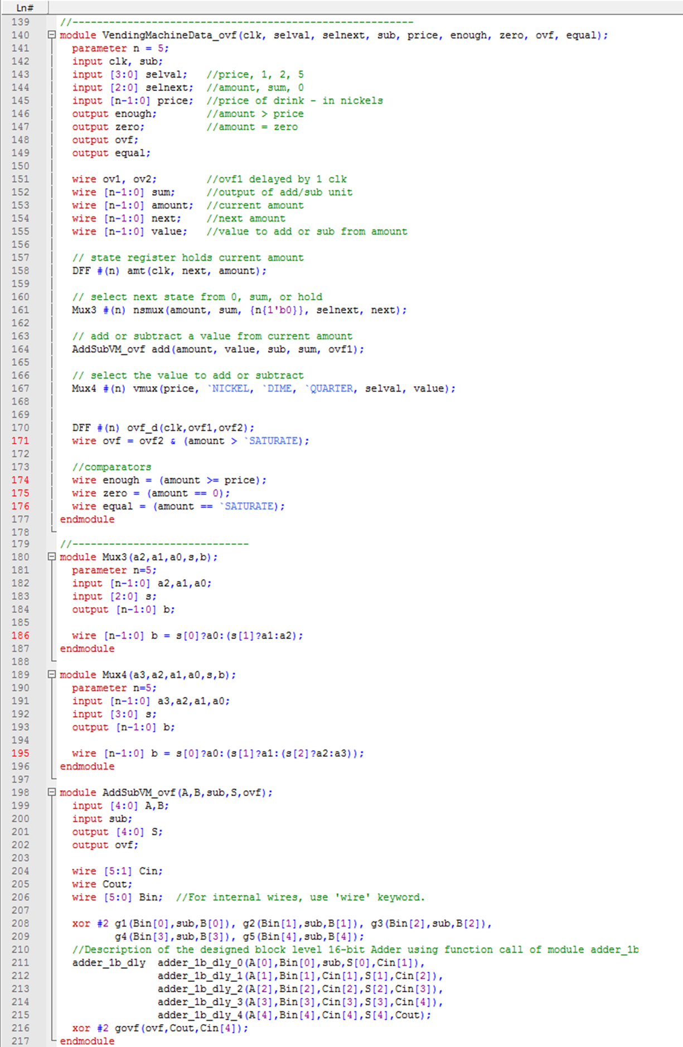

1. **Modification of Testbench of Vending Machine_pla in Verilog for overflow**

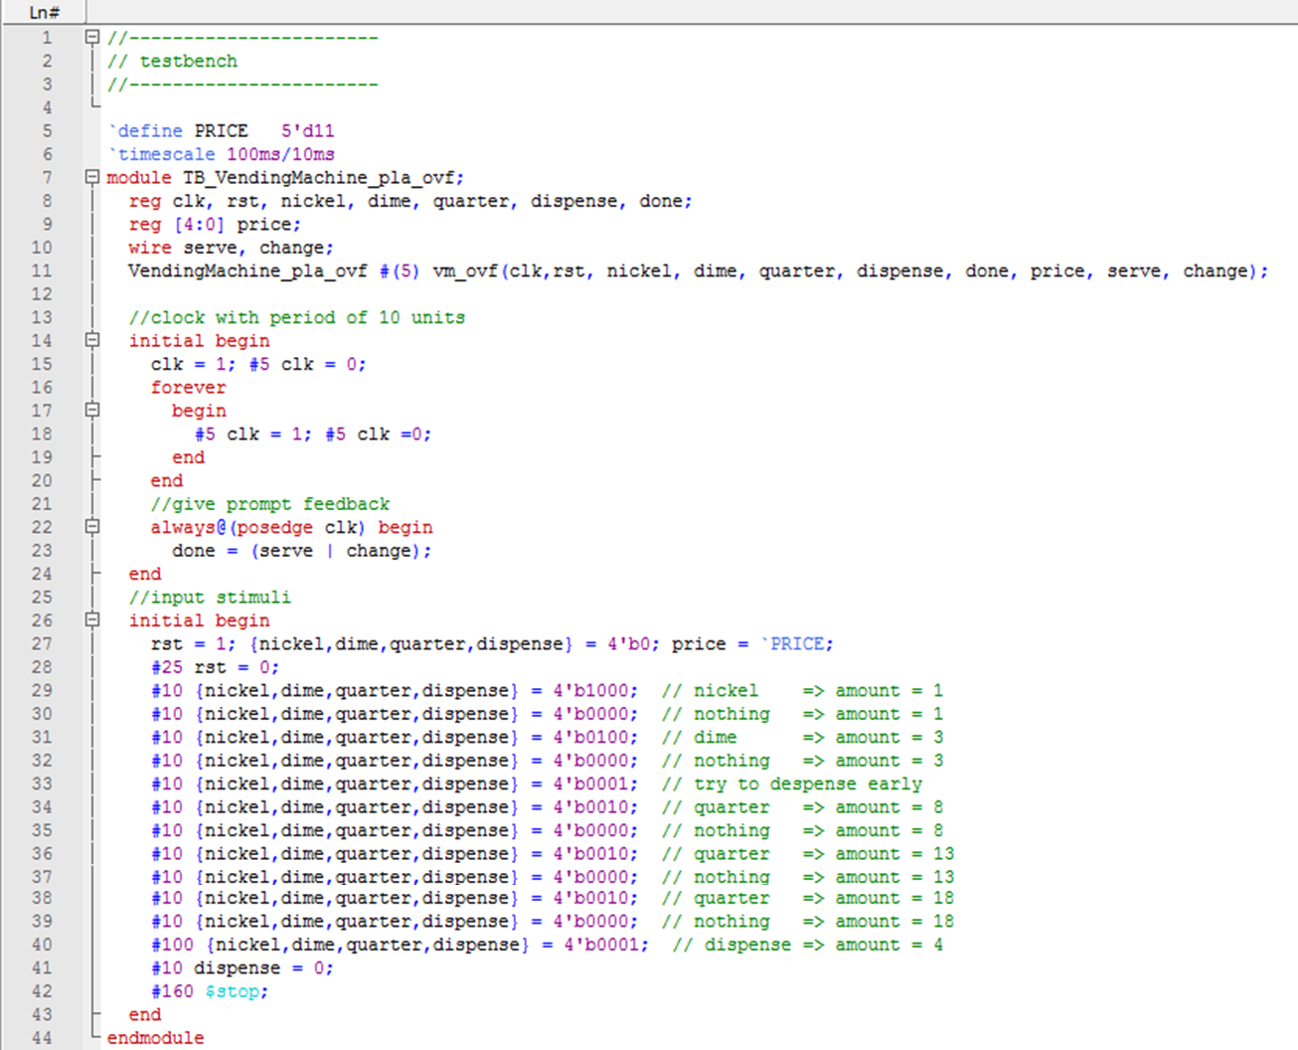

1. **Waveforms of the Modified Overflow Vending Machine with PLA**

